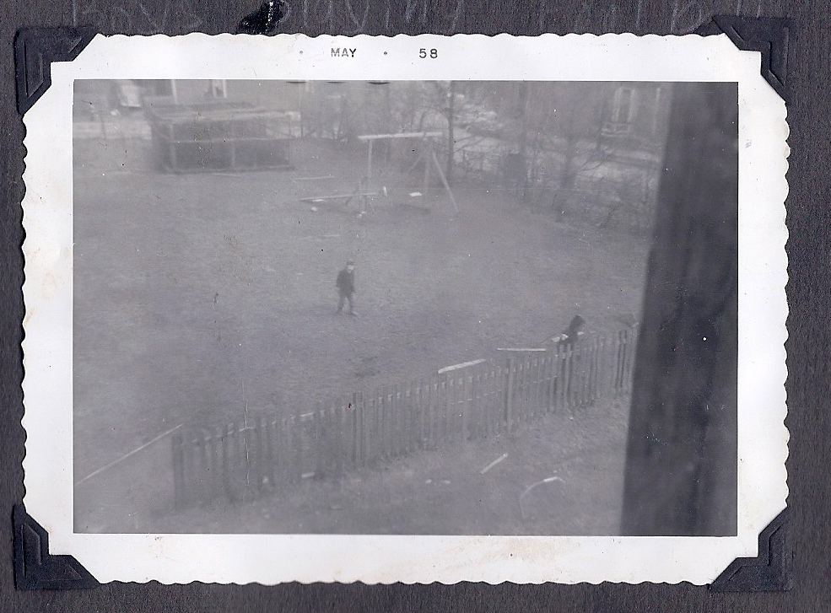

grounds of 106 Pennywell Road from the bedroom window looking east

3 – the Green Gate – brothers playing soccer
pine hatchery and swings and seesaw in background

